STEP 1: DOWNALOAD HIBERNATE JAR FILES

LINK: <https://jar-download.com/artifacts/org.hibernate/hibernate-core>

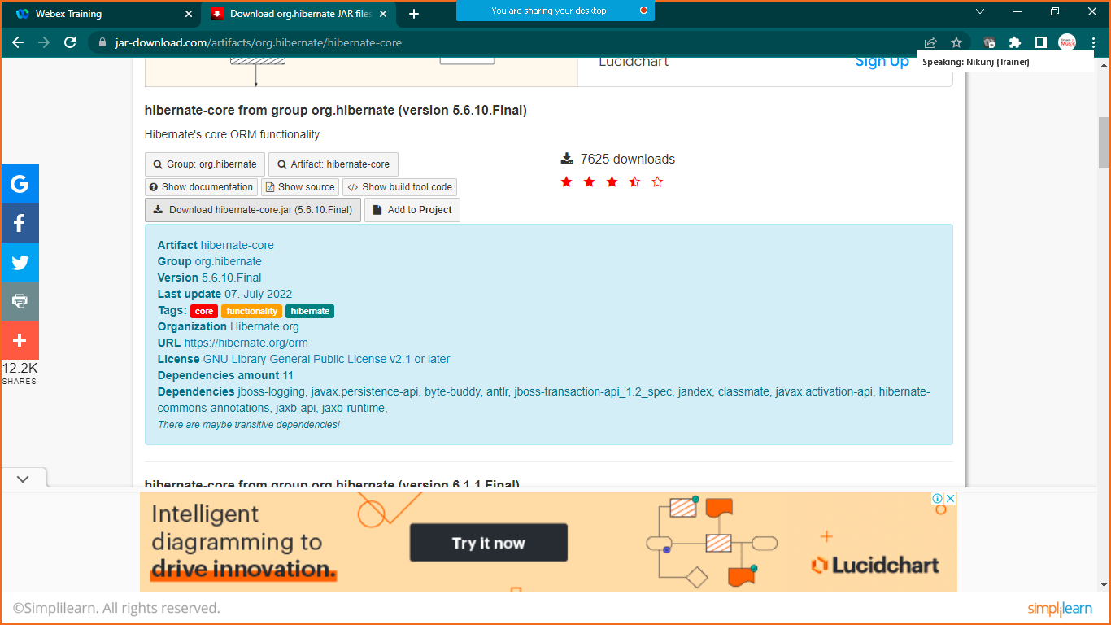

STEP: 2 EXTACT FILES TO ONE FOLDER

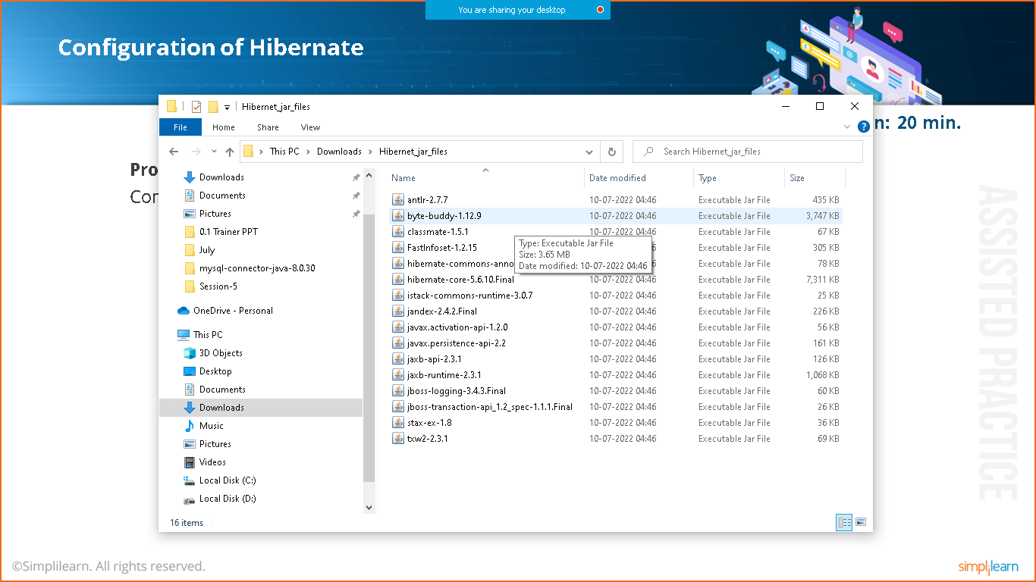

STEP:3 CREATE SIMPLE JAVA PROJECT

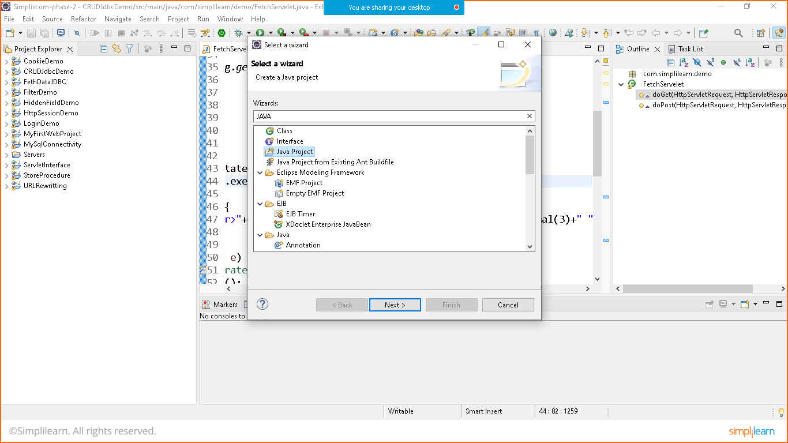

Name: HibernateJavaProject

STEP4: ADD LIBRARIES

Goto>project>rightclick>buildpath>configure buildpath>select library tab>classpath>clickon add externaljar

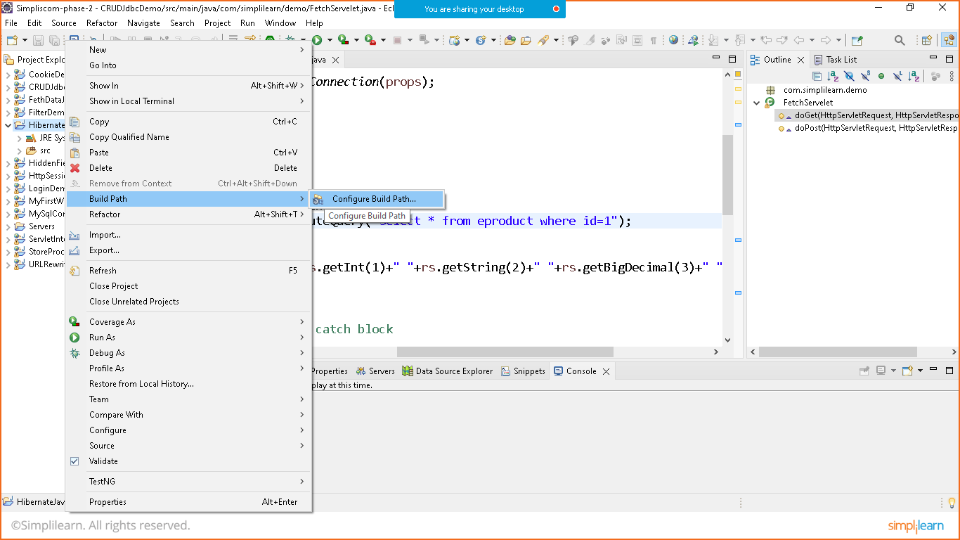

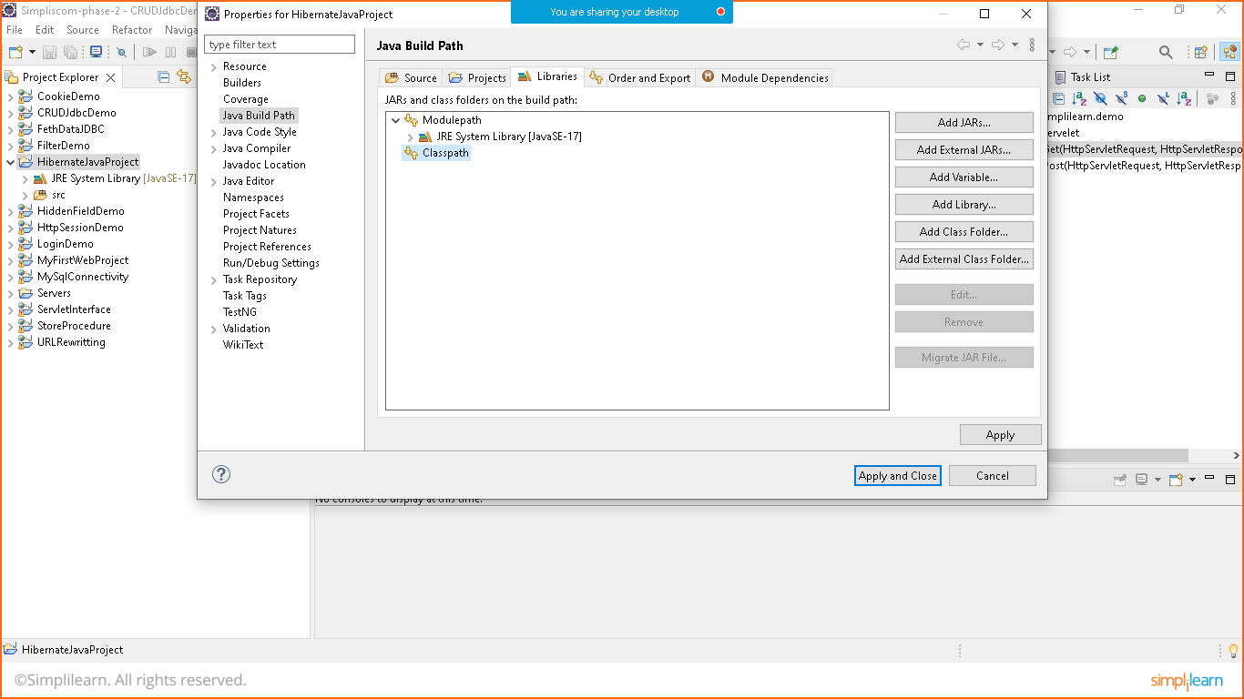

Add mysql-connector jar file and hibernate jar files to the library

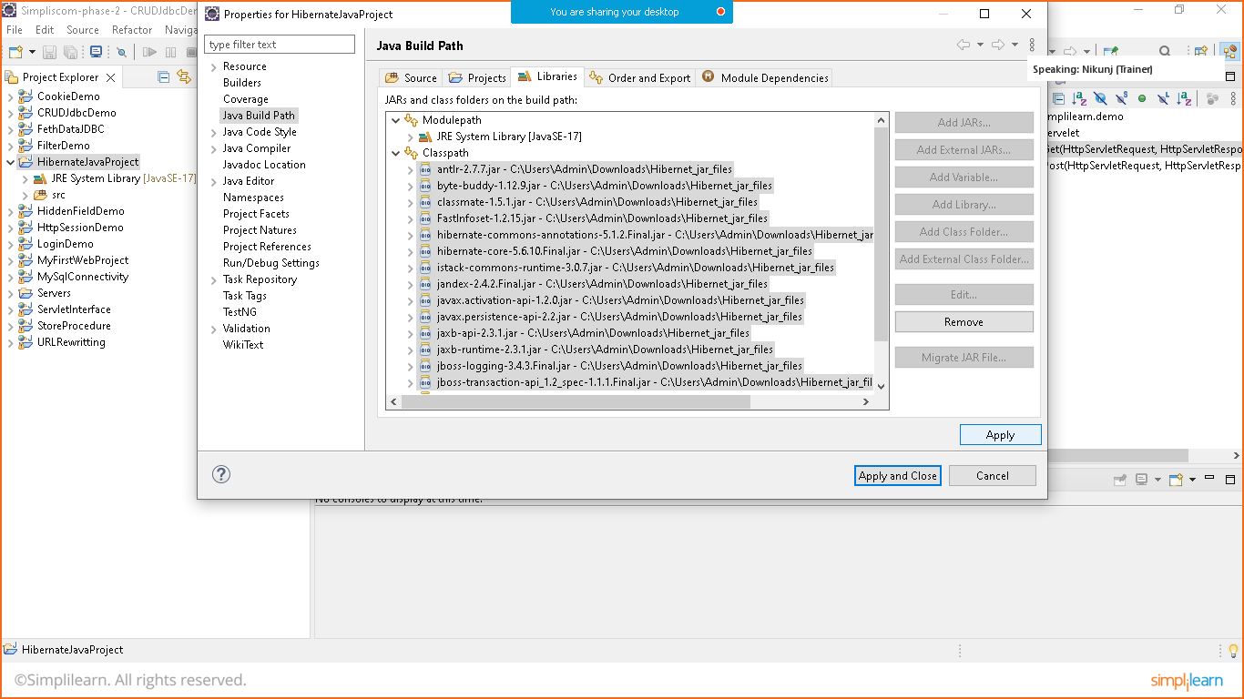click on apply and apply and close

STEP:5 PREPARE CONFIGURATION FILE

Right click on >src>new>others>xmlfile>hibernate.cfg.xml

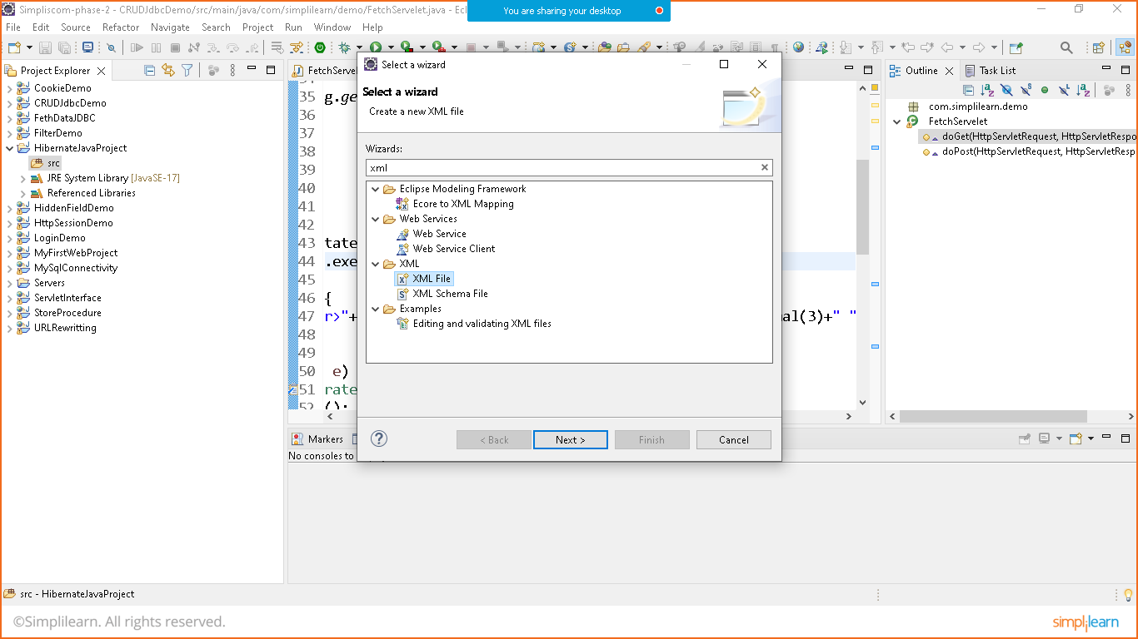

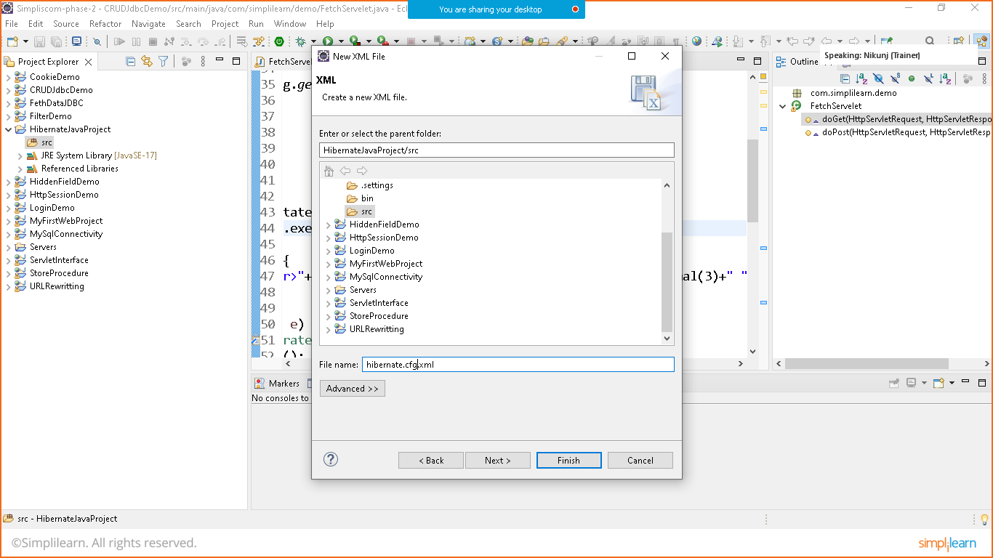

Add hibernate configuration

This can be done in two ways either we find solution online or we can copy it from jar files

To copy configuration

Goto reference libraries>hibernatecore-5.0>org.hibernate>scroll to bottom and open hibernate-configuration.dtd file

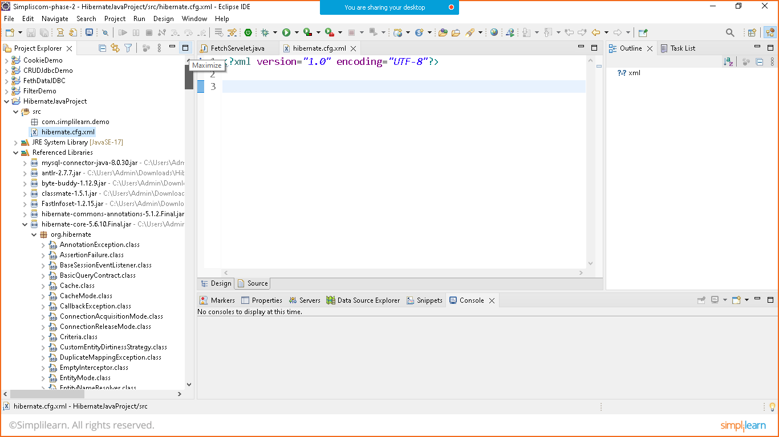

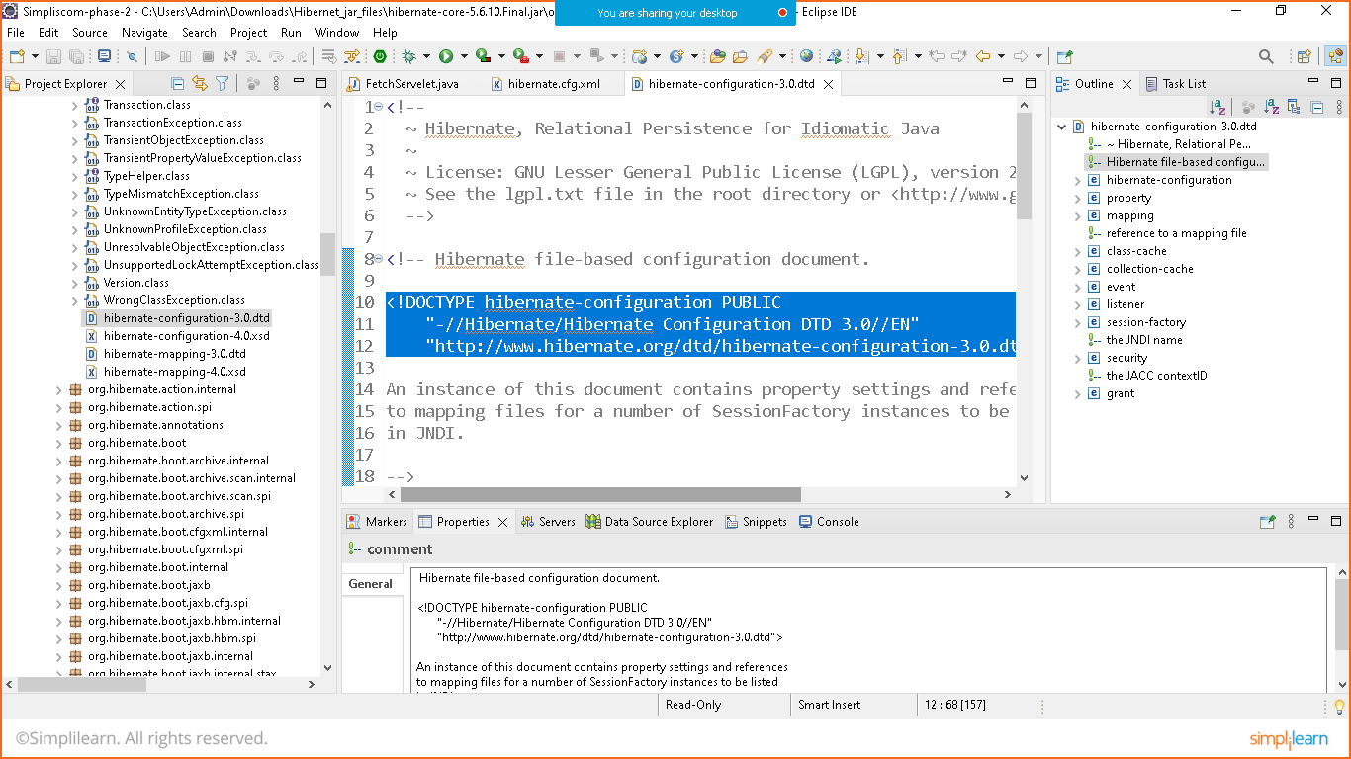

Copy the part of configuration as shown above to hibernate.cfg.xml file

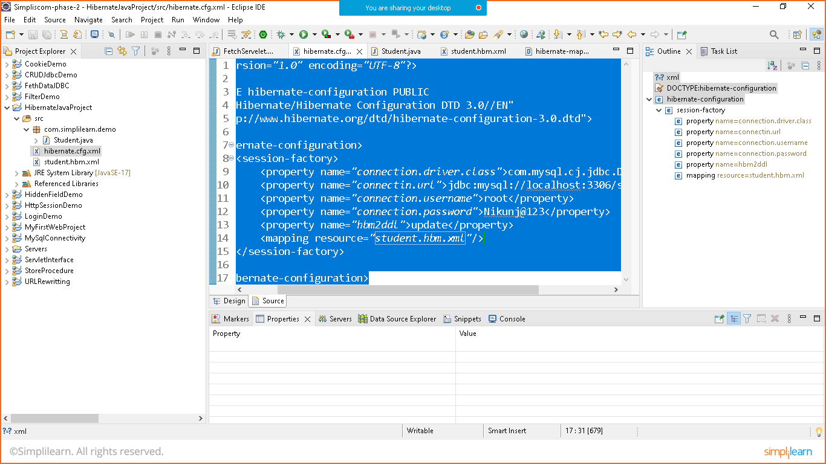

Hibernate.cfg.xml

<?xml version=*"1.0"* encoding=*"UTF-8"*?>

<!DOCTYPE hibernate-configuration PUBLIC

"-//Hibernate/Hibernate Configuration DTD 3.0//EN"

"http://www.hibernate.org/dtd/hibernate-configuration-3.0.dtd">

<hibernate-configuration>

<session-factory>

<property name=*"connection.driver.class"*>com.mysql.cj.jdbc.Driver</property>

<property name=*"connection.url"*>jdbc:mysql://localhost:3306/student_hibernate</property>

<property name=*"connection.username"*>root</property>

<property name=*"connection.password"*>Nikunj@123</property>

<property name=*"hbm2ddl.auto"*>update</property>

<mapping resource=*"student.hbm.xml"*/>

</session-factory>

</hibernate-configuration>

STEP:6 CREATE POJO BEAN CLASS

Create student class

Src>new>class>Student

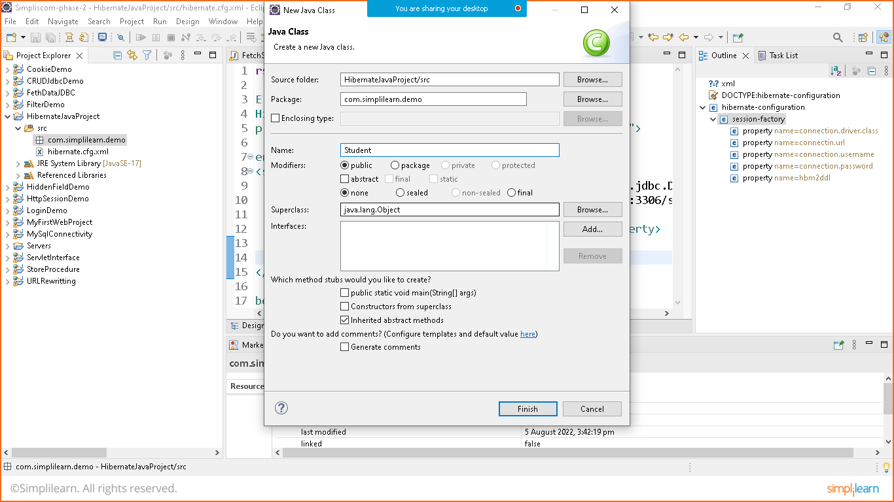

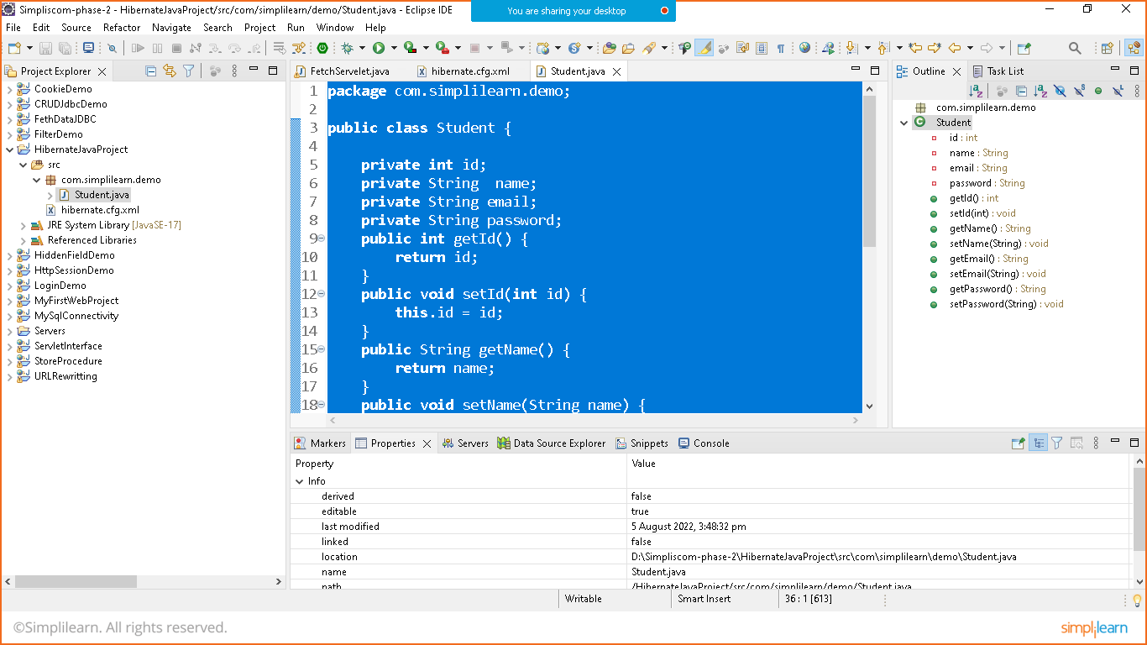

**package** com.simplilearn.demo;

**public** **class** Student {

**private** **int** id;

**private** String name;

**private** String email;

**private** String password;

**public** **int** getId() {

**return** id;

}

**public** **void** setId(**int** id) {

**this**.id = id;

}

**public** String getName() {

**return** name;

}

**public** **void** setName(String name) {

**this**.name = name;

}

**public** String getEmail() {

**return** email;

}

**public** **void** setEmail(String email) {

**this**.email = email;

}

**public** String getPassword() {

**return** password;

}

**public** **void** setPassword(String password) {

**this**.password = password;

}

}

STEP:7 PREPARE MAPPING FOR CLASS

Right click src>new>others>xml>sdtuent.hbm.xml

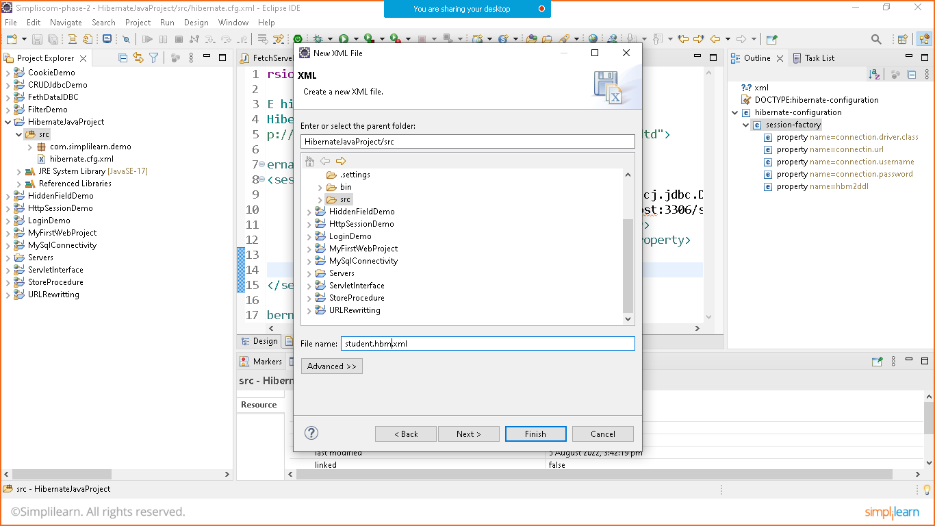

Add hibernate mapping

This can be done in two ways either we find solution online or we can copy it from jar files

To copy configuration

Goto reference libraries>hibernatecore-5.0>org.hibernate>scroll to bottom and open hibernate-mapping.dtd file

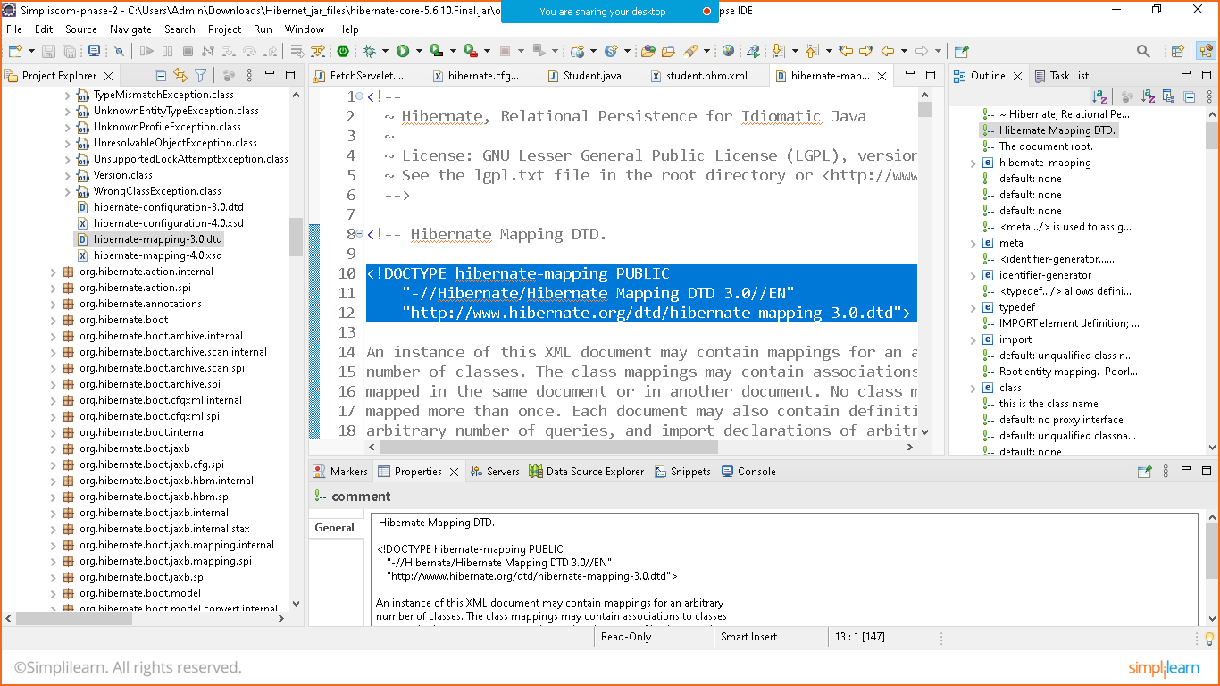

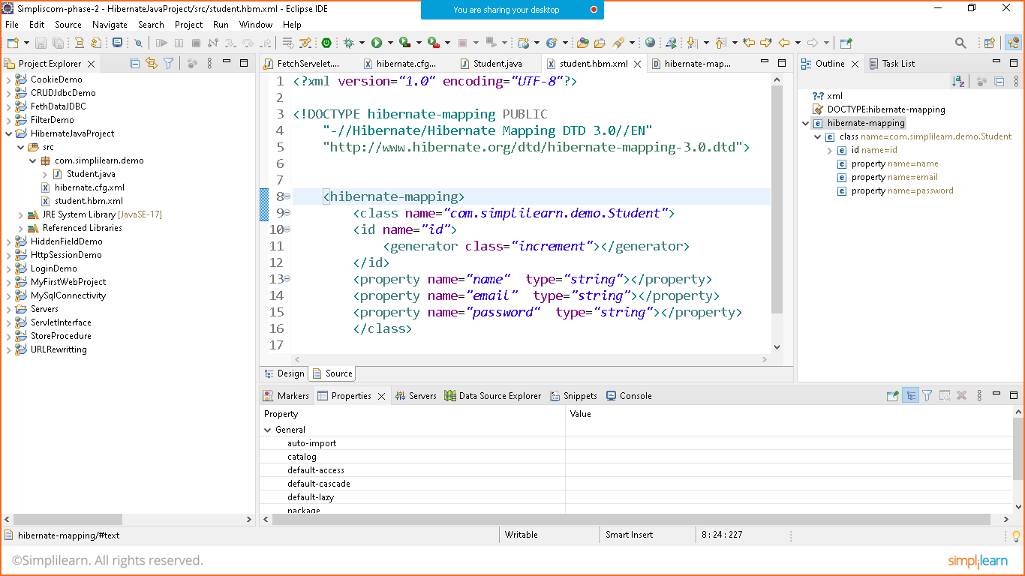

Student.hbm.xml

<?xml version=*"1.0"* encoding=*"UTF-8"*?>

<!DOCTYPE hibernate-mapping PUBLIC

"-//Hibernate/Hibernate Mapping DTD 3.0//EN"

"http://www.hibernate.org/dtd/hibernate-mapping-3.0.dtd">

<hibernate-mapping>

<class name=*"com.simplilearn.demo.Student"*>

<id name=*"id"*>

<generator class=*"increment"*></generator>

</id>

<property name=*"name"* type=*"string"*></property>

<property name=*"email"* type=*"string"*></property>

<property name=*"password"* type=*"string"*></property>

</class>

</hibernate-mapping>

STEP:8 CREATE MAIN CLASS TO CHECK THE OUTPUT

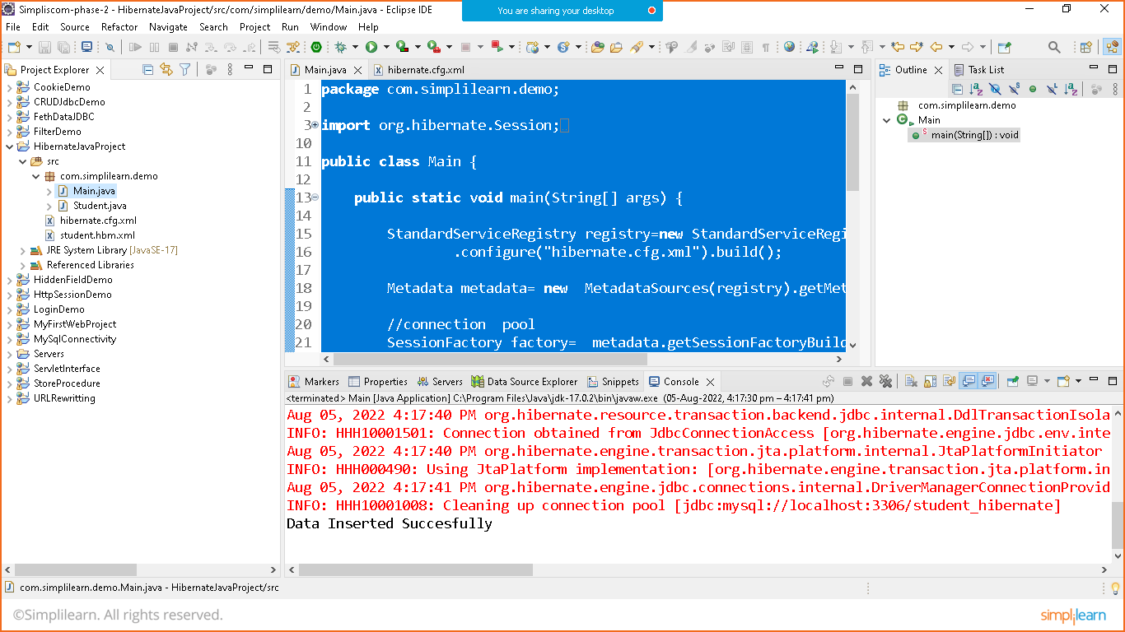

Main.class

package com.simplilearn.demo;

import org.hibernate.Session;

import org.hibernate.SessionFactory;

import org.hibernate.Transaction;

import org.hibernate.boot.Metadata;

import org.hibernate.boot.MetadataSources;

import org.hibernate.boot.registry.StandardServiceRegistry;

import org.hibernate.boot.registry.StandardServiceRegistryBuilder;

public class Main {

public static void main(String[] args) {

StandardServiceRegistry registry=new StandardServiceRegistryBuilder()

.configure("hibernate.cfg.xml").build();

Metadata metadata= new MetadataSources(registry).getMetadataBuilder().build();

//connection pool

SessionFactory factory= metadata.getSessionFactoryBuilder().build();

//let's take database connection to do transection

//prepare one databse in mysql with name Student_hibernate before execution of below command

Session session= factory.openSession();

Student s1=new Student();

s1.setName("Nikunj Soni");

s1.setEmail("nikunj@123");

s1.setPassword("Nikunj@123");

Transaction tx= session.beginTransaction();

session.save(s1);

tx.commit();

//automatically prepare the table and insert the data automatically

session.close();

factory.close();

System.out.println("Data Inserted Succesfully");

}

}

STEP:9 RUN THE PROGRAM

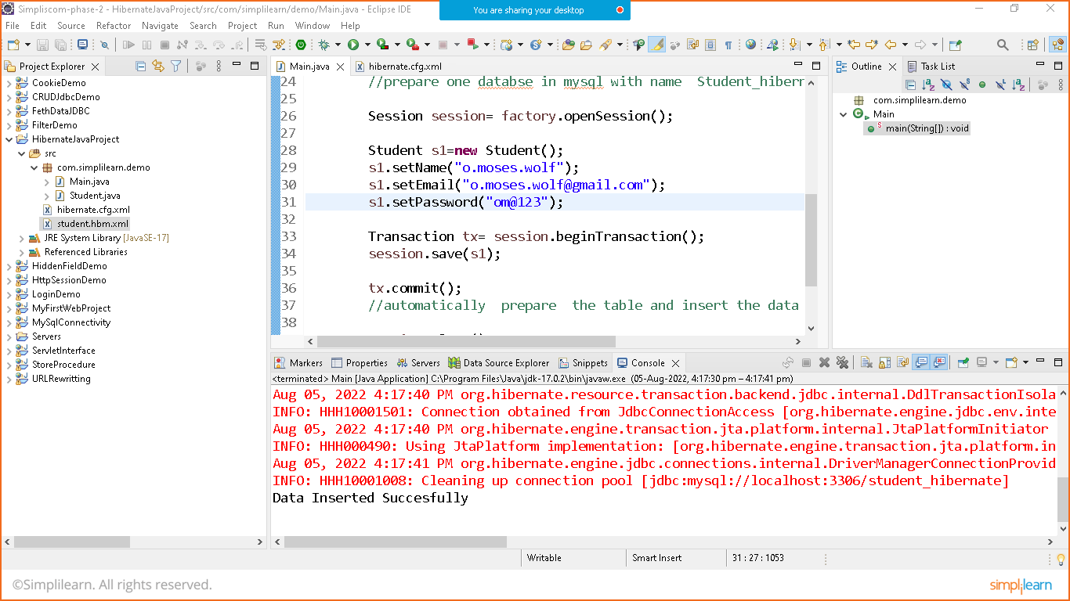

Check the database

